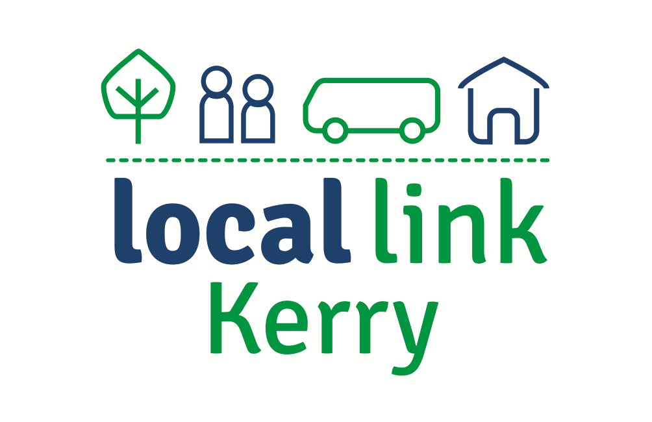
Call: 066-7147002
Email: info@locallinkkerry.ie
Web: www.locallinkkerry.ie

College or Training Centre Questionnaire 2019

Name: __________________________________________
- What College/Training Centre do you attend?
Choose an item.
- How many days a week do you attend?
Choose an item.
- What time do you need to reach your destination?
Choose an item.
Other (Please State) Click or tap here to enter text.
- What time are you finished?
Choose an item.
Other (Please State) Click or tap here to enter text.

- What is your primary mode of transport to your College/Training centre?
Choose an item.
Other (Please State) Click or tap here to enter text.

- From where do you regularly travel to your College/Training centre?
Choose an item.
Please State Town/Village Click or tap here to enter text.

- How would you rate the convenience of your chosen method of transport?
Choose an item.
Comment: Click or tap here to enter text.

- Is public transport your first choice for travel to your educational/training centre.
Choose an item.
- If Public Transport is your first choice, please state why?
Comment: Click or tap here to enter text.

- If Public Transport is not your first choice, please state why?
Comment: Click or tap here to enter text.

- If provided, would you avail of a Park and Ride facility on the outskirts of Tralee?
Choose an item.

Please complete and return to servicedev@locallinkkerry.ie

Signed: _____________________________ Date: _________________________

