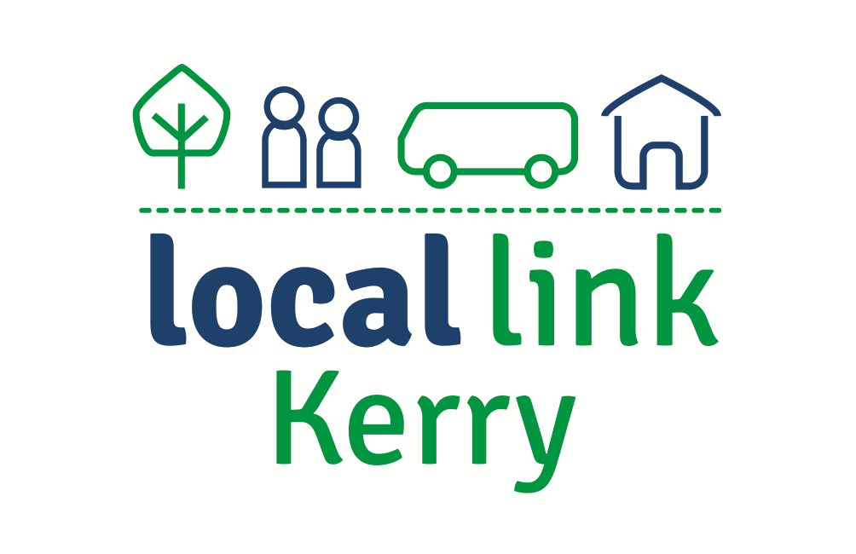
Call: 066-7147002
Email: info@locallinkkerry.ie
Web: www.locallinkkerry.ie

Passenger Questionnaire 2019

Name/Address:
Contact No:

- Please indicate how many people of each age group live in your house?
Comment:

- Are you aware of Local Link Kerry bus services?
Comment:

- If you were to use Local Link Kerry bus services, for what reason would you travel with us?
Reasons for Travel:
- If you have not used Local Link Kerry bus services, what limits your use of the services?
Comment:
- Do you require assistance with travelling?
Choose an item.

- Please indicate the main town or village you would like to get to on a regular basis and the below additional information?
- Town or Village: Click or tap here to enter text.
- Days of the Week: Click or tap here to enter text.
- No of Days: Click or tap here to enter text.
- Time of the Day: Click or tap here to enter text.

- Please indicate if you would be a fare paying passenger or travelling by free travel pass?
Choose an item.

- Have you any suggestions or comments to make regarding the improvement of rural transport services in Co Kerry?
Comment:
Signed: _____________________________ Date: _________________________

Please complete this form and return to servicedev@locallinkkerry.ie

