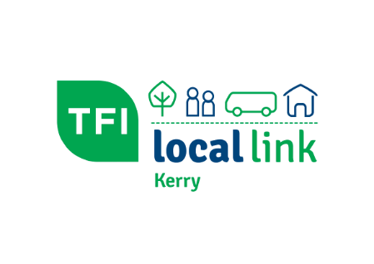 | Social Inclusion Transport Support-2023  Transport Support Request Form

- Group/Organisation details

Group/Organisation Name
Postal Address

Group/Organisation contact person details
Contact Name
Position in Group/Organisation
Telephone Number
Email Address

- Is your group a member of Kerry Public Participation Network (Kerry PPN)?
Yes |  |  | No

- Statement of why transport support is needed: Activities planned must demonstrate a clear fit with social inclusion objectives.

- Statement of likely impact of transport supports: Please describe the anticipated impact and benefit for your group/organisation.

- Transport service details ( please supply all information)**
Day and Date of Service
Outline of Service

Start Time and Location of Bus
Depart Time for Return Journey
Total Number of Passengers
Additional Pick Up Point |  | Time
Itinerary for Day if Applicable ( day trips with stops) |  | Time

**Please reference Section 10 for a summary of our Terms & Conditions. For full details refer to the ‘Eligibility and Specific conditions of Offer’ document.

- Vehicle details
Do you require any of the following?
Wheelchair Accessible Vehicle |  | No. of Wheelchair Passengers*
Boot Storage for Bags / Cases
Other Special Requirements
*we may need further details regarding the type and size of the Wheelchairs

- Unmet transport needs
Please identify or let us know if there is need for a community / public transport services in your area.

- Invoice details
TFI Local Link Kerry will issue an invoice to the group/organisation for the transport service provided after the service has taken place.
Please provide the following details to assist us in issuing invoice (if details are the same as Section 1, please leave boxes below blank)

Contact Name
Position in Group/Organisation

Group/Organisation Name

Postal Address

Telephone Number

Email Address
Purchase Order Number
(if applicable)

- Confirmation

I ___________________________________ (block capitals) on behalf of above named group/organisation CONFIRM that I
(Please tick boxes below)
- Have read and agree with the Eligibility & Specific Conditions of Offer document □

- Accept that TFI Local Link Kerry will securely retain completed applications for audit purposes □

- Accept the contact details (name, contact no) of the applicant, will be shared with the Operator and Driver relating to this trip only and TFI LLK will not share with any other company or organisation other than for audit purposes □
- Will complete a feedback questionnaire after the service, if requested□

- Acknowledge TFI Local Link Kerry in any social media or print features relating to this service. □

Submitted by: |  | Contact number:
Signed: |  | Date:

The Transport Support Request form is to be submitted by, E Mail onceoffservices@locallinkkerry.ie with subject – Social Inclusion Transport Support Request or by post to TFI Local Link Kerry, Island Point, Tralee Road Industrial Estate, Tralee Road, , Castleisland, Co. Kerry, V92 E894, five working days in advance of proposed services operating. Failure to do so may result in TFI Local Link Kerry not being able to process the request.

Office Use Only:
Mileage:
Percentage:

BDM Sign Off:
GM Sign Off:

